**STOCK PRICE PREDICTION USING MACHINE LEARNING**

# **ABSTRACT**

This project explores stock price prediction using machine learning techniques to improve forecasting accuracy. We evaluated traditional algorithms such as Random Forest Regressor and Support Vector Regression (SVR), which yielded Mean Squared Errors (MSE) of 85.57 and 2878.20, respectively. To enhance performance, we implemented advanced models including Long Short-Term Memory (LSTM) networks, Stacked LSTM, Gated Recurrent Units (GRU), and Stacked GRU, alongside the Autoregressive Integrated Moving Average (ARIMA) model. The LSTM and its stacked variant achieved validation losses of 0.5048 and 0.9658, while the GRU and Stacked GRU models demonstrated even better results with validation losses of 0.0101 and 0.0361, respectively. ARIMA also performed notably well, with a Mean Squared Error of 11.86. The dataset utilized comprises 2417 entries with features including Adj Close, Open, High, Low, Close, and Volume. These results indicate significant improvements in prediction accuracy with the proposed models.

**KEYWORDS:** Stock price, Machine learning, LSTM, GRU, Mean square error, Forecasting Stock.

**STATEMENT ABOUT THE PROBLEM**

Accurate stock price prediction remains a significant challenge due to the complex and volatile nature of financial markets. Traditional forecasting methods often fall short in capturing the intricate patterns and temporal dependencies in stock price data. Existing algorithms, such as Random Forest Regressor and Support Vector Regression (SVR), provide limited accuracy, with high Mean Squared Errors indicating suboptimal performance. To address these limitations, this project seeks to leverage advanced machine learning techniques, including LSTM, Stacked LSTM, GRU, and Stacked GRU models, alongside ARIMA, to improve prediction accuracy and reliability for stock price forecasting.

**WHY IS THE PARTICULAR TOPIC CHOSEN?**

The topic of stock price prediction using machine learning is chosen due to its critical importance in financial markets and the ongoing quest for more accurate forecasting methods. Traditional approaches often struggle with the dynamic and non-linear characteristics of stock price movements, leading to suboptimal predictions. Machine learning offers advanced techniques that can better capture complex patterns and temporal dependencies in financial data. By exploring models such as LSTM, Stacked LSTM, GRU, and Stacked GRU, this project aims to address the limitations of conventional methods and enhance prediction accuracy. Additionally, the inclusion of ARIMA provides a comparative baseline. The choice of this topic is driven by the potential to significantly improve decision-making for investors and analysts, thereby contributing to more informed trading strategies and financial planning.

**SCOPE**

The scope of this project encompasses the development and evaluation of various machine learning models for predicting stock prices. It includes implementing and comparing traditional forecasting algorithms, such as Random Forest Regressor and Support Vector Regression (SVR), with advanced models like Long Short-Term Memory (LSTM), Stacked LSTM, Gated Recurrent Units (GRU), and Stacked GRU. Additionally, the project incorporates the Autoregressive Integrated Moving Average (ARIMA) model for baseline comparison. The dataset used features six attributes—Adj Close, Open, High, Low, Close, and Volume—spanning 2417 entries. The project aims to assess the performance of these models through metrics such as Mean Squared Error (MSE) and validation loss, identifying the most effective approach for accurate stock price prediction. The ultimate goal is to enhance forecasting accuracy, providing valuable insights for investors and financial analysts.

**OBJECTIVE OF THE PROJECT**

The objective of this project is to significantly improve the accuracy of stock price predictions by leveraging advanced machine learning techniques. Initially, the project evaluates traditional forecasting models such as Random Forest Regressor and Support Vector Regression (SVR) to establish baseline performance metrics. Building on this foundation, the project focuses on implementing and optimizing sophisticated models, including Long Short-Term Memory (LSTM), Stacked LSTM, Gated Recurrent Units (GRU), and Stacked GRU, to better capture the complex patterns and temporal dynamics inherent in stock price movements. Additionally, the Autoregressive Integrated Moving Average (ARIMA) model is used as a comparative benchmark. The ultimate goal is to identify the most effective model that minimizes Mean Squared Error (MSE) and validation loss, thereby enhancing the reliability of stock price forecasts. This improvement aims to support more informed decision-making for investors and financial analysts, providing them with better tools for financial planning and strategy.

# **EXISTING METHOD**

The existing methods for stock price prediction primarily involve traditional machine learning algorithms such as Random Forest Regressor and Support Vector Regression (SVR). Random Forest Regressor utilizes ensemble learning to improve prediction accuracy through decision trees, while SVR applies support vector machines to handle non-linear relationships. Although these methods are widely used, they often struggle with capturing complex temporal dependencies in stock price data, leading to limited forecasting accuracy. The Mean Squared Error (MSE) values from these models indicate their constraints, highlighting the need for more advanced approaches to improve prediction performance.

# **DISADVANTAGES**

**Limited Accuracy**: Traditional models like Random Forest Regressor and SVR often struggle to accurately predict stock prices due to their inability to capture complex patterns and trends in financial data.

**High Error Rates**: The Mean Squared Error (MSE) from these models can be relatively high, indicating that their predictions are not very precise and can be unreliable for making informed decisions.

**Inability to Handle Non-Stationarity**: Stock prices are influenced by various factors that change over time, and traditional methods may not effectively adapt to these dynamic changes.

**Difficulty with Temporal Patterns**: These models have challenges in understanding the sequential and time-dependent nature of stock price movements, which can lead to poor forecasting performance.

**Lack of Flexibility**: Traditional methods may not easily incorporate additional features or adapt to new data trends, limiting their effectiveness as market conditions evolve.

# **PROPOSED SYSTEM**

The proposed system aims to enhance stock price prediction accuracy by utilizing advanced machine learning models, specifically Long Short-Term Memory (LSTM), Stacked LSTM, Gated Recurrent Units (GRU), and Stacked GRU, alongside the Autoregressive Integrated Moving Average (ARIMA) model. Unlike traditional methods, these models are designed to capture complex temporal dependencies and dynamic patterns in stock price data. LSTM and its stacked variant are adept at remembering long-term dependencies, while GRU and Stacked GRU offer efficiency in learning sequential data. ARIMA serves as a benchmark to compare the effectiveness of these advanced models. By integrating these techniques, the proposed system aims to significantly reduce Mean Squared Error (MSE) and validation loss, thereby providing more reliable and accurate stock price forecasts

# **ADVANTAGES**

**Improved Accuracy**: Advanced models like LSTM and GRU offer better prediction accuracy by capturing complex patterns and temporal dependencies in stock price data.

**Enhanced Adaptability**: These models can adapt to changing market conditions and incorporate new data trends more effectively.

**Lower Error Rates**: Reduced Mean Squared Error (MSE) and validation loss lead to more precise and reliable forecasts.

**Better Handling of Sequential Data**: LSTM and GRU models excel in processing and learning from sequential and time-dependent data, improving forecast quality.

**Comprehensive Analysis**: The inclusion of ARIMA provides a comparative benchmark, ensuring a thorough evaluation of model performance and enhancing overall forecasting reliability.

# **BLOCK DIAGRAM**

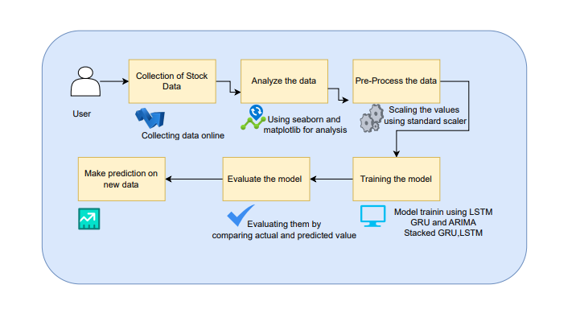

**APPLICATIONS**

1. Investment Decision-Making: Investors can use the improved stock price predictions to make more informed decisions about buying or selling stocks, potentially increasing their investment returns.

2. Financial Planning: Financial analysts can leverage accurate forecasts to better plan and strategize for future market conditions, helping clients achieve their financial goals.

3. Risk Management: Accurate stock price predictions can help businesses and investors manage financial risks by providing better insights into potential market fluctuations.

4. Trading Strategies: Traders can use the advanced predictions to develop and refine trading strategies, aiming for more profitable trades based on predicted price movements.

5. Market Analysis: Financial institutions and research firms can utilize the enhanced forecasting models to analyze market trends and gain a competitive edge in understanding market dynamics.

**FLOW DIAGRAM**

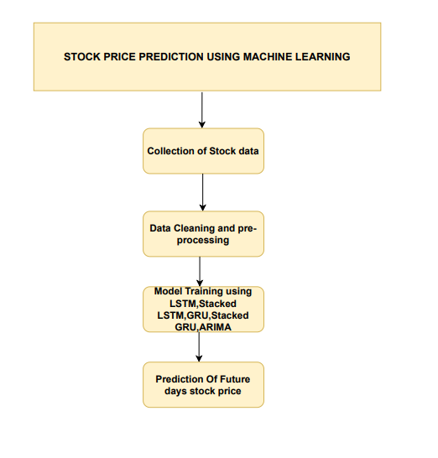

**SOFTWARE HARDWARE REQUIREMENTS**

**H/W CONFIGURATION:**

Processor - I3/Intel Processor

Hard Disk - 160GB

Key Board - Standard Windows Keyboard

Mouse - Two or Three Button Mouse

Monitor - SVGA

RAM - 8GB

**S/W CONFIGURATION:**

* Operating System : Windows 7/8/10
* Server side Script : HTML, CSS, Bootstrap & JS
* Programming Language : Python
* Libraries : Flask, Pandas, MySQL. Connector, Tensor flow, Keras
* IDE/Workbench : VS Code
* Technology : Python 3.8+
* Server Deployment : Xampp Server

**MODULES**

* **Data Collection**: This module is responsible for gathering historical stock price data from internet. It ensures the dataset includes relevant features such as Adj Close, Open, High, Low, Close, and Volume.
* **Preprocessing**: In this stage, the collected data is cleaned and prepared for modeling. Tasks include handling missing values, normalizing or scaling data, and splitting it into training and testing sets to ensure accurate model evaluation.
* **Modeling**: This module involves developing and training machine learning models. It includes implementing algorithms such as Random Forest Regressor, Support Vector Regression (SVR), LSTM, Stacked LSTM, GRU, and Stacked GRU. The models are tuned and optimized to achieve the best performance in predicting stock prices.
* **Prediction**: Once models are trained, this module is used to generate predictions based on new or unseen data. It outputs forecasted stock prices and evaluates the model's performance using metrics like Mean Squared Error (MSE) and validation loss.

**2. User Modules:**

* **Login**: This module allows users to securely access the system by verifying their credentials. It ensures that only registered users can access the platform.
* **Register**: New users can create an account through this module by providing necessary details such as username, password, and email. It facilitates user onboarding and account management.
* **User Home**: After logging in, users are directed to the home page, which provides an overview of their account and access to various features of the system.
* **Prediction Page**: This page allows users to input data and initiate stock price predictions. Users can select the desired model and view the forecasted results based on their inputs.
* **Result Page**: The result page displays the outcomes of the stock price predictions. It provides detailed information on the predicted values, model performance metrics, and any relevant visualizations to help users interpret the results effectively.

# **LEARNING OUTCOMES**

1. Understanding Advanced Models: Gain knowledge of advanced machine learning models such as LSTM, Stacked LSTM, GRU, and Stacked GRU, and how they are applied to time-series data for stock price prediction.

2. Data Handling Skills: Learn how to preprocess and prepare financial data for analysis, including techniques for cleaning, normalizing, and splitting datasets.

3. Model Evaluation: Develop skills in evaluating model performance using metrics like Mean Squared Error (MSE) and validation loss, and understand how to interpret these metrics to improve prediction accuracy.

4. Application of Machine Learning: Understand how to implement and optimize different machine learning algorithms for practical applications in financial forecasting and prediction.

5. System Integration: Learn how to integrate various system components, from data collection and preprocessing to model training and user interface design, to build a complete stock price prediction system.